SEC Form 3
FORM 3 | UNITED STATES SECURITIES AND EXCHANGE COMMISSION
 | Washington, D.C. 20549
 | Washington, D.C. 20549 |  | OMB APPROVAL
 | INITIAL STATEMENT OF BENEFICIAL OWNERSHIP OF SECURITIES
 | INITIAL STATEMENT OF BENEFICIAL OWNERSHIP OF SECURITIES |  | OMB Number: | 3235-0104
 |  |  | Estimated average burden
 | Filed pursuant to Section 16(a) of the Securities Exchange Act of 1934 |  | hours per response: | 0.5
or Section 30(h) of the Investment Company Act of 1940
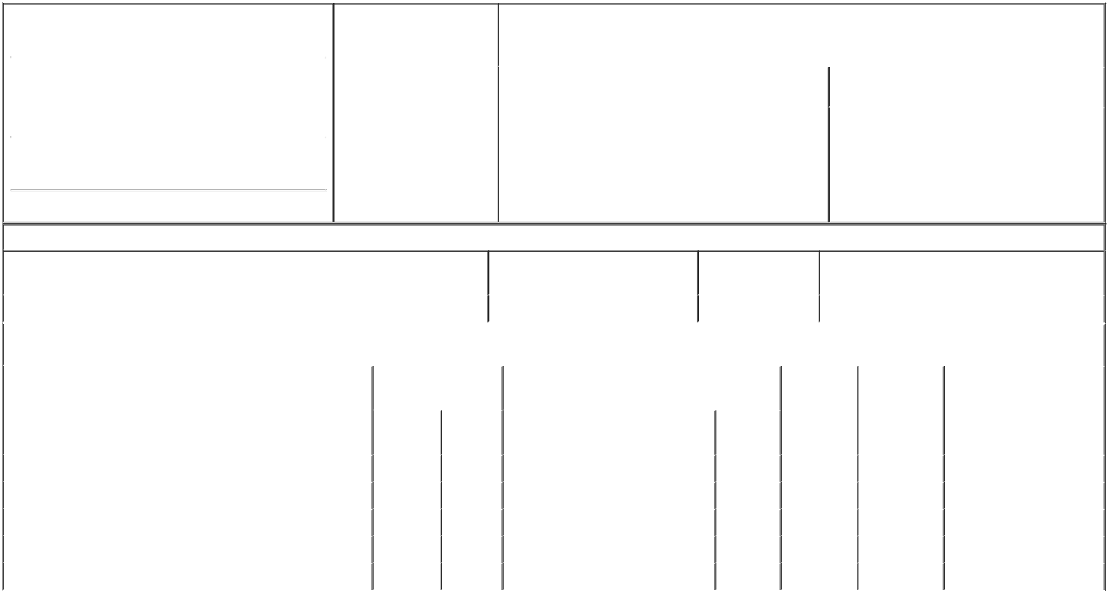

1. Name and Address of Reporting Person* |  |  |  |  | 2. Date of Event Requiring
 |  | Brown Oscar K |  |  | Statement (Month/Day/Year)
 |  | Brown Oscar K |  | 12/31/2023
 |  | (Last) | (First) | (Middle)
 |  | 6&8 EAST COURT SQUARE
 |  | SUITE 300
(Street)
 |  | NEWNAN | GA | 30263

3. |  | Issuer Name and Ticker or Trading Symbol
FREYR Battery, Inc. /DE/ [ FREY ]
4. |  | Relationship of Reporting Person(s) to Issuer |  |  |  | 5. | If Amendment, Date of Original Filed (Month/Day/Year)
(Check all applicable)
 |  |  | Director |  | 10% Owner
 |  | X | Officer (give title |  | Other (specify below) | 6. | Individual or Joint/Group Filing (Check Applicable Line)
 |  | X | below) |  | Other (specify below) |  | X Form filed by One Reporting Person
 |  |  | Chief Financial Officer |  |  |  | Form filed by More than One Reporting Person

(City) (State) (Zip)

Table I - Non-Derivative Securities Beneficially Owned

1. Title of Security (Instr. 4) | 2. Amount of Securities Beneficially | 3. Ownership Form: | 4. Nature of Indirect Beneficial Ownership (Instr. 5)
 | Owned (Instr. 4) | Direct (D) or Indirect
 |  | (I) (Instr. 5)

 | Shares of Common Stock⁽¹⁾ |  |  |  | 60,000 | D
 |  |  | Table II - Derivative Securities Beneficially Owned
 |  | (e.g., puts, calls, warrants, options, convertible securities)
 | 1. Title of Derivative Security (Instr. 4) |  | 2. Date Exercisable and |  | 3. Title and Amount of Securities Underlying |  | 4. | 5. Ownership | 6. Nature of Indirect Beneficial
 |  |  | Expiration Date |  | Derivative Security (Instr. 4) |  | Conversion | Form: Direct | Ownership (Instr. 5)
 |  |  | (Month/Day/Year) |  |  |  | or Exercise | (D) or Indirect
 |  |  |  |  |  |  | Price of | (I) (Instr. 5)
 |  |  |  |  |  | Amount or | Price of | (I) (Instr. 5)
 |  |  |  |  |  | Amount or | Derivative
 |  |  | Date | Expiration | Title | Number of | Security
 |  |  | Exercisable | Date | Title | Shares
 | Stock Options (right to buy) | (2) |  | 05/09/2027 | Shares of Common Stock⁽³⁾ | 250,000 | 7.39 | D
 | Stock Options (right to buy) | (4) |  | 06/09/2027 | Shares of Common Stock⁽³⁾ | 225,000 | 8.47 | D
 | Stock Options (right to buy) | (5) |  | 05/22/2028 | Shares of Common Stock⁽³⁾ | 300,000 | 7.55 | D
 | Restricted Stock Units (RSU) | (6) |  | (6) | Shares of Common Stock⁽³⁾ | 40,596 | (7) | D
 | Restricted Stock Units (RSU) | (8) |  | (8) | Shares of Common Stock⁽³⁾ | 80,863 | (7) | D
 | Explanation of Responses:

- As described in the issuer's registration statement on Form S-4 (File No. 333-274434) (the "Registration Statement"), following the redomiciliation of FREYR Battery, the issuer's predecessor registrant (the "Predecessor Registrant") from Luxembourg to the State of Delaware on December 31, 2023 (the "Redomiciliation"), each of the issued and outstanding ordinary shares of the Predecessor Registrant ("Ordinary Shares") immediately prior to the Redomiciliation, were canceled and the issuer issued as consideration therefor new duly authorized, validly issued, fully paid and non-assessable common stock of the issuer, par value $0.01 per share (the "Common Stock"), to the shareholders of the Predecessor Registrant on a one-to-one basis.

- Consists of compensatory options which vest annually over three years granted on May 9, 2022 pursuant to the FREYR 2021 LTIP (as defined herein). One-third (1/3) of the shares subject to compensatory options vested on May 9, 2023. One-third (1/3) of the shares subject to compensatory options vested on May 9, 2024. One-third (1/3) of the shares subject to compensatory options shall vest on May 9, 2025. Options are typically forfeited when the employment relationship ends for employees.

- As described in the issuer's Registration Statement, following the Redomiciliation, each right and obligation under the Predecessor Registrant's equity-based benefit and compensation plans and programs and agreements providing for the grant or award of restricted stock, stock units, stock options, warrants, stock appreciation rights, performance shares, performance units, dividend equivalent rights, and share awards, including the FREYR 2021 Equity Incentive Plan (amended and restated as of May 10, 2023) (the "FREYR 2021 LTIP"), was assumed by the issuer and converted to a corresponding equity award with respect to shares of the Common Stock on a one-to-one basis and each equity or equity-based award granted under the Predecessor Registrant was canceled and the recipient had no right or interest in such award or any underlying Ordinary Shares other than receipt of a corresponding equity or equity-based award with respect to Common Stock.

- Consists of compensatory options which vest annually over three years granted on June 9, 2022 pursuant to the FREYR 2021 LTIP. One-third (1/3) of the shares subject to compensatory options vested on June 9, 2023. One-third (1/3) of the shares subject to compensatory options shall vest on June 9, 2024. One-third (1/3) of the shares subject to compensatory options shall vest on June 9, 2025. Options are typically forfeited when the employment relationship ends for employees.

- Consists of compensatory options which vest annually over three years granted on May 22, 2023 pursuant to the FREYR 2021 LTIP. One-third (1/3) of the shares subject to compensatory options shall vest on May 22, 2024. One-third (1/3) of the shares subject to compensatory options shall vest on May 22, 2025. One-third (1/3) of the shares subject to compensatory options shall vest on May 22, 2026. Options are typically forfeited when the employment relationship ends for employees.

- The cash-settled restricted stock units ("RSUs") will vest ratably over three years from the May 9, 2022 grant date. One-third (1/3) of the units vested on May 9, 2023. One-third (1/3) of the units shall vest on May 9, 2024. One-third (1/3) of the units shall vest on May 9, 2025.

- The RSUs will be settled solely in cash. Each cash-settled RSU is the economic equivalent of one share of Common Stock as of the time of vesting and settlement as determined by the terms of the applicable Restricted Stock Unit Award Agreement.

- The cash-settled RSU swill vest ratably over three years from the May 9, 2023 grant date. One-third (1/3) of the units shall vest on May 9, 2024. One-third (1/3) of the units shall vest on May 9, 2025. One-third (1/3) of the units shall vest on May 9, 2026.

Remarks:

Exhibit List Exhibit 24.1 - Power of Attorney

 | /s/ Oscar Brown |  | 01/10/2024
 | ** Signature of Reporting Person |  | Date
Reminder: Report on a separate line for each class of securities beneficially owned directly or indirectly.
* If the form is filed by more than one reporting person, see Instruction 5 (b)(v).
** Intentional misstatements or omissions of facts constitute Federal Criminal Violations See 18 U.S.C. 1001 and 15 U.S.C. 78ff(a).
Note: File three copies of this Form, one of which must be manually signed. If space is insufficient, see Instruction 6 for procedure.
Persons who respond to the collection of information contained in this form are not required to respond unless the form displays a currently valid OMB Number.



