UNITED STATES
SECURITIES AND EXCHANGE COMMISSION
Washington, D.C. 20549

FORM 8-K

CURRENT REPORT

PURSUANT TO SECTION 13 OR 15(d) OF THE
SECURITIES EXCHANGE ACT OF 1934

Date of Report (Date of earliest event reported): August 12, 2026

T1 Energy Inc.
(Exact name of registrant as specified in its charter)

Delaware |  | 001-41903 |  | 93-3205861
(State or other jurisdiction  of incorporation) |  | (Commission File Number) |  | (IRS Employer  Identification No.)

1211 E 4th St.
Austin, Texas 78702
(Address of principal executive offices, including zip code)

Registrant’s telephone number, including area code: 409-599-5706

(Former name or former address, if changed since last report)

Check the appropriate box below if the Form 8-K filing is intended to simultaneously satisfy the filing obligation of the registrant under any of the following provisions:

 | ☐ | Written communications pursuant to Rule 425 under the Securities Act (17 CFR 230.425)

 | ☐ | Soliciting material pursuant to Rule 14a-12 under the Exchange Act (17 CFR 240.14a-12)

 | ☐ | Pre-commencement communications pursuant to Rule 14d-2(b) under the Exchange Act (17 CFR 240.14d-2(b))

 | ☐ | Pre-commencement communications pursuant to Rule 13e-4(c) under the Exchange Act (17 CFR 240.13e-4(c))

Securities registered pursuant to Section 12(b) of the Act:

Title of each class |  | Trading Symbol(s) |  | Name of each exchange on which registered
Common Stock, $0.01 par value |  | TE |  | The New York Stock Exchange

Indicate by check mark whether the registrant is an emerging growth company as defined in Rule 405 of the Securities Act of 1933 (§ 230.405 of this chapter) or Rule 12b-2 of the Securities Exchange Act of 1934 (§ 240.12b-2 of this chapter).

Emerging growth company ☐

If an emerging growth company, indicate by check mark if the registrant has elected not to use the extended transition period for complying with any new or revised financial accounting standards provided pursuant to Section 13(a) of the Exchange Act. ☐

Item 2.02. Results of Operations and Financial Condition.

On August 12, 2026, T1 Energy Inc., a Delaware corporation (the “Company”), issued a press release announcing its financial results for the quarter ended June 30, 2026. A copy of the press release is attached hereto as Exhibit 99.1 to this Current Report on Form 8-K and is incorporated herein by reference.

The information in this Item 2.02, including the Exhibit 99.1 attached hereto, is being furnished and shall not be deemed “filed” for purposes of Section 18 of the Securities Exchange Act of 1934, as amended (the “Exchange Act”), nor shall it be deemed incorporated by reference in any filing under the Securities Act of 1933, as amended (the “Securities Act”), except as shall be expressly set forth by specific reference in such filing.

Item 7.01. Regulation FD Disclosure.

The Company is furnishing its earnings call presentation for the quarter ended June 30, 2026 (the “Presentation”), attached as Exhibit 99.2 to this Current Report on Form 8-K, which may be referred to on the Company’s conference call for the financial results for the quarter ended June 30, 2026 to be held on August 12, 2026. The Presentation will also be available on the Company’s website at https://www.t1energy.com.

The information in this Item 7.01, including the Exhibit 99.2 attached hereto, is being furnished and shall not be deemed “filed” for purposes of Section 18 of the Exchange Act, nor shall it be deemed incorporated by reference in any filing under the Securities Act, except as shall be expressly set forth by specific reference in such filing.

Item 9.01. Financial Statements and Exhibits.

(d) Exhibits.

Exhibit No. |  | Description
99.1 |  | Press release, dated August 12, 2026, reporting T1 Energy Inc.’s financial results for the quarter ended June 30, 2026.
99.2 |  | Earnings call presentation for the quarter ended June 30, 2026.
104 |  | Cover Page Interactive Data File (embedded within the Inline XBRL document).

1

SIGNATURE

Pursuant to the requirements of the Securities Exchange Act of 1934, the registrant has duly caused this report to be signed on its behalf by the undersigned, hereunto duly authorized.

 | T1 Energy Inc.
 | By: | /s/ Evan Calio
 |  | Name: | Evan Calio
 |  | Title: | Chief Financial Officer

Dated: August 12, 2026

2

Exhibit 99.1

 | News Release

T1 Energy Reports Second Quarter 2026 Results

Austin, TX and New York, NY, August 12, 2026, T1 Energy Inc. (NYSE: TE) (“T1,” “T1 Energy,” or the “Company”) today reported financial and operating results for the second quarter 2026. The Company will hold a conference call today at 8:00 am EDT.

Headlines

 | § | Second quarter 2026 results summary. During Q2 2026, T1 achieved total net sales of $250.1 million, G1_Dallas module production of 935 MW, a net loss from continuing operations of $(36.9) million, and Adjusted EBITDA of $10.7 million. The Company’s second quarter 2026 net loss from continuing operations and Adjusted EBITDA included a pre-tax reduction in Cost of Sales due to $24.4 million of tariff refunds recognized during the quarter.

 | § | T1 and Clearway execute strategic offtake deal. In August 2026, T1 announced a contract to supply independent power producer Clearway Energy Group (“Clearway”) 641 MW of solar modules built with domestic cells from T1’s G2_Austin solar cell fab. This latest offtake contract marks a continuation of T1’s commercial strategy to offer customers a traceable and reliable solar supply chain built on leading U.S. technology and domestic content.

 | § | T1 acquires advanced solar intellectual property rights from Evervolt. In July 2026, the Company announced that it acquired foundational solar patents and other intellectual property rights from Evervolt Green Energy Holding Pte Ltd. (“Evervolt”) for total consideration of $135 million. T1 believes these patents, which relate to Tunnel Oxide Passivated Contact (“TOPCon”) solar cells and modules, provide the most advanced, highly efficient commercially viable solar technology available.

 | § | G2_Austin project update. Construction work on the 2.1 GW Phase 1 of G2_Austin, T1’s solar cell fab, continues with the building ready for interior Mechanical, Electrical and Plumbing installation. Additionally, T1 has begun receiving the first containers of production line equipment at U.S. ports, and all the key shipments from T1’s production line equipment vendor for Phase 1 are now either on the water or already in the United States. Long lead time clean room equipment has also been ordered ahead of the projected start of clean room installation later in the third quarter. As the Company indicated in July, T1 is projecting that capital expenditures for G2_Austin Phase 1 will total $510 million in accordance with the recent addition of a 20% contingency. The capital expenditure contingency is intended to account for labor and materials costs associated with tightness in the Texas data center construction market. T1 expects to produce the first solar cells at G2_Austin in Q1 2027.

 | § | T1 applauds the Section 232 proclamation in support of American polysilicon solar manufacturing. The Company believes the new action, which was signed and announced on August 6, 2026, aligns with T1’s strategy to build a vertically integrated solar supply chain on industry leading U.S. technology. The proclamation details new tariffs on U.S. imports of polysilicon and polysilicon derivatives, which go into effect on December 4, 2026. It also launches an onshoring program to incentivize companies to invest in U.S. production of polysilicon products. T1 plans to work with the Department of Commerce to access the tariff offset onshoring program through T1’s committed and planned investments in G2_Austin, TOPCon IP, and U.S. polysilicon and wafer commitments with Hemlock Semiconductor and Corning, Inc. (NYSE: GLW).

“We made significant advances during and since the second quarter to strengthen T1’s long-term competitive position while we fund and execute our domestic vertical integration strategy,” said Dan Barcelo, Chairman and CEO of T1 Energy. “Our mission to power America with industry leading solar technology while we support the domestic polysilicon industry is resonating with customers, and we are focused on delivering strong operational and financial performance in the second half of 2026 while we continue to make meaningful progress at G2_Austin, our flagship U.S. solar cell fab.”

T1 Energy Inc. | 1 | News Release

Business update and guidance

 | § | Nordic value optimization. T1 is engaged in discussions with multiple parties to explore potential strategic pathways to generate value from the Company’s Nordic portfolio. T1’s Nordic data center asset, which has been assigned a 50 MW grid allocation by Norway’s power grid operator, remains in the queue for 396 MW of power. Potential monetization structures could include participation in a joint venture through T1’s contribution of assets with established operators in the global data center ecosystem.

 | § | Section 45X tax credits. During Q2 2026, T1 monetized the balance of the Company's remaining 2025 Section 45X tax credits (as defined below) for $39.1 million, at a gross price of $0.93 on the dollar, which was higher than previously announced 2025 sales. T1 has also commenced early-stage negotiations with several potential counterparties regarding sales of Section 45X tax credits accrued in 2026.

 | § | Enhanced full-year 2026 G1_Dallas production target. T1 expects the run rate of production in Q3 and Q4 2026 will exceed Q2 2026 production and believes 2026 production will fall within the higher end of its previously disclosed 2026 production range of 3.1 - 4.2 GW. The enhanced production target reflects T1's progress qualifying international cell vendors to supply G1_Dallas.

 | § | Financing update. T1 continues to target a comprehensive financing solution, which includes a significant debt component, in an amount sufficient to fund the remaining estimated capital expenditure required for G2_Austin Phase 1.

Subsequent Events to Q2 2026

 | § | T1 completed a private placement of $120 million of convertible senior notes due 2031. In July 2026, the Company completed a private placement of $120 million aggregate principal amount of its 4.75% convertible senior notes due 2031. The offering generated gross proceeds of $120 million and is intended as a bridge to a comprehensive financing solution to fund the remaining capital expenditures of the 2.1 GW Phase 1 of G2_Austin.

 | § | T1 closes acquisition of KORE Power, Inc., creating T1 NRI brand to service BESS and data center infrastructure markets. In July 2026, T1 closed the previously announced acquisition of KORE Power, Inc. The transaction is expected to provide T1 with an entry point into the energy storage and AI data center infrastructure markets through an expanded potential customer base for solar and storage solutions.

Q2 2026 Results Overview

 | § | T1 Energy reported a net loss attributable to common stockholders for the second quarter of 2026 of $44.5 million, or $(0.16) per share compared to a net loss of $32.8 million, or $(0.21) per share for the second quarter of 2025. Net loss from continuing operations was $36.9 million, or $(0.14) per share for the second quarter of 2026 compared to a net loss from continuing operations of $31.2 million, or $(0.21) per share for the second quarter of 2025. Net loss from discontinued operations was $6.6 million, or $(0.02) per share for the second quarter of 2026 compared to a net loss of $0.7 million, or $(0.00) per share for the second quarter of 2025.

 | § | As of June 30, 2026, T1 had cash, cash equivalents, and restricted cash of $156.4 million, of which $79.1 million was unrestricted cash.

T1 Energy Inc. | 2 | News Release

Presentation of Second Quarter 2026 Results

A presentation will be held today, August 12, 2026, at 8:00 am Eastern Daylight Time to discuss financial and operating results for the second quarter 2026. The results and presentation material will be available for download at https://ir.t1energy.com/.

Participants can access the conference call by clicking the following link and completing the online registration form. Upon registering participants will receive the dial-in info and PIN to join the call.

The call will also be available by clicking the webcast link.

About T1 Energy

T1 Energy Inc. (NYSE: TE) is an energy solutions provider building an integrated U.S. supply chain for solar. In December 2024, T1 completed a transformative transaction, positioning the Company as one of the leading solar manufacturing companies in the U.S., with a complementary solar and storage strategy. Based in the U.S. with plans to expand its operations in America, the Company is also exploring value optimization opportunities across its portfolio of assets in Europe.

To learn more about T1, please visit www.T1energy.com and follow on social media.

Investor contact:

Jeffrey Spittel

EVP, Investor Relations and Corporate Development
jeffrey.spittel@T1energy.com
Tel: +1 409 599-5706

Media contact:

Russell Gold

EVP, Strategic Communications
russell.gold@T1energy.com
Tel: +1 214 616-9715

T1 Energy Inc. | 3 | News Release

Cautionary Statement Concerning Forward-Looking Statements:

This press release contains forward-looking statements within the meaning of the Private Securities Litigation Reform Act of 1995. All statements contained in this press release that do not relate to matters of historical fact should be considered forward-looking statements, including without limitation with respect to T1’s strategy of developing as an integrated U.S. solar and storage leader, powering U.S. artificial intelligence development and energy dominance and establishing a domestic solar supply chain (including its desired position as the first vertically integrated American silicon-based advanced solar company); T1’s ability to build commercial traction with U.S. customers; T1’s ability to generate meaningful long-term shareholder value; the timing for funding and completion of G2_Austin Phase 1 and the expected level of capital expenditure to achieve such completion; expectations with respect to future financing activities (including the structure, timing and size of any such transaction); T1’s financial and operating performance and guidance (including 2026 operating and financial guidance) and any projected business outlook; the negotiation of sales of Section 45X tax credits accrued in 2026; the expected benefits from T1’s acquisition of patents and other intellectual property rights from Evervolt; the impact of the Section 232 polysilicon proclamation, including anticipated benefits to T1’s supply chain strategy and T1’s ability to access the Department of Commerce tariff offset onshoring program; the growth of U.S. electricity demand; T1’s commercial presence and ability to grow its U.S. customer base; T1’s ability to meet its production plan and pursue strategic partnerships, including the status of any ongoing discussions with utilities/developers (including with respect to T1’s portfolio of European assets); T1’s capital formation opportunities and the timing thereof; any cell procurement targets and indications of customer demand in 2026; T1’s ability to optimize its capital structure; the ramp up of production and revenues at G1_Dallas (including the timing for module production); any commercial funnel of sales opportunities for 2026 and beyond (including customer pursuits, advanced opportunities and ongoing discussions with customers); the expected benefits from the acquisition of KORE Power, Inc.; and T1’s ability to meet its strategic priorities to fund and build T1’s integrated polysilicon solar supply chain and enhance its profitability and capital structure. These forward-looking statements are based on management’s current expectations. These statements are neither promises nor guarantees, but involve known and unknown risks, uncertainties and other important factors that may cause actual future events, results, or achievements to be materially different from T1’s expectations and projections expressed or implied by the forward-looking statements. Important factors include, but are not limited to, those discussed under the caption “Risk Factors” in T1's Annual Report on Form 10-K for the year ended December 31, 2025 filed with the U.S. Securities and Exchange Commission (the “SEC”) on March 31, 2026, as amended and supplemented by Amendment No. 1 on Form 10-K/A filed with the SEC on April 30, 2026, including risks related to: (1) T1's ability to (i) construct and equip manufacturing facilities in a timely and cost-effective manner; (ii) target and retain customers and suppliers; (iii) attract and retain key employees and qualified personnel; (iv) protect its intellectual property; (v) comply with legal and environmental regulations; (vi) compete in international markets in light of export and import controls; (vii) incur substantially more debt; (viii) remediate the material weakness in T1's internal control over financial reporting or otherwise maintain effective internal control over financial reporting, (ix) qualify for the advanced manufacturing production credit under Section 45X of the Internal Revenue Code of 1986, as amended (the ”Section 45X tax credits”), and (x) rely on third-party warranties; (2) T1’s ability to secure a comprehensive financing solution to fund the remaining capital expenditure for G2_Austin Phase 1 on favorable terms, or at all, and the timing of such financing; (3) the concentration of T1's operations in Texas and its dependence on a limited number of suppliers; (4) changes adversely affecting the flow of components and materials from international vendors, the costs of raw materials, components, equipment, and machinery; (5) general economic and geopolitical conditions, (6) changes in applicable laws or regulations, including environmental, export control and tax laws and incentives and renewable energy targets, as well as international trade policies, including tariffs, on T1's products and competitive position (including T1’s ability to obtain tariff refunds); (7) the outcome of any legal proceedings relating to T1's products and services, including intellectual property or product liability claims, commercial or contractual disputes, warranty claims, and other proceedings; and (8) the capital-intensive nature of T1's business and its ability to raise additional capital on attractive terms or service its debt.

The above referenced filings are available on the SEC’s website at www.sec.gov. Forward-looking statements speak only as of the date of this press release and are based on information available to T1 as of the date of this press release, and T1 assumes no obligation to update such forward-looking statements, all of which are expressly qualified by the statements in this section, whether as a result of new information, future events or otherwise, except as required by law.

T1 Energy Inc. | 4 | News Release

T1 intends to use its website as a channel of distribution to disclose information which may be of interest or material to investors and to communicate with investors and the public. Such disclosures will be included on T1’s website in the ‘Investor Relations’ section. T1, and its CEO and Chairman of the Board, Daniel Barcelo, also intend to use certain social media channels, including, but not limited to, X, LinkedIn and Instagram, as means of communicating with the public and investors about T1, its progress, products, and other matters. While not all the information that T1 or Daniel Barcelo post to their respective digital platforms may be deemed to be of a material nature, some information may be. As a result, T1 encourages investors and others interested to review the information that it and Daniel Barcelo posts and to monitor such portions of T1’s website and social media channels on a regular basis, in addition to following T1’s press releases, SEC filings, and public conference calls and webcasts. The contents of T1’s website and its and Daniel Barcelo’s social media channels shall not be deemed incorporated by reference in any filing under the Securities Act of 1933, as amended.

Use of Non-GAAP Financial Measures

T1 reports financial results in accordance with generally accepted accounting principles in the United States (“GAAP”). Adjusted EBITDA presented herein is a supplemental measure of T1’s performance that is not required by, or presented in accordance with, GAAP. The presentation of this non-GAAP financial measure is not intended to be considered in isolation or as a substitute for, or superior to, financial information prepared and presented in accordance with GAAP.

T1 defines Adjusted EBITDA as net income (loss) from continuing operations before interest expense, income tax expense (benefit), depreciation and amortization, and further adjusted to exclude certain items that management does not consider indicative of the Company’s core operating performance, including, but not limited to, non-cash charges, non-recurring items, and non-operating gains or losses. These adjustments include impairment charges, losses on debt extinguishment, losses on settlement of derivative liabilities, share-based compensation, fair value adjustments of warrant and derivative liabilities, and non-recurring transaction expenses. Our Adjusted EBITDA measure was re-defined in the fourth quarter of 2025 to also exclude certain non-recurring transaction expenses. The historical presentation of Adjusted EBITDA in this press release has been recast to conform to the revised definition.

T1 uses Adjusted EBITDA as a key measure in evaluating its financial and operating performance and in making strategic business decisions. T1 believes that Adjusted EBITDA, when considered together with the corresponding GAAP financial measures, provides meaningful supplemental information by excluding items that may not be representative of its core business, operating results, or future outlook. However, Adjusted EBITDA is not a measure of financial performance under GAAP and should not be considered as an alternative to net income (loss) from continuing operations or any other measure of performance or liquidity presented in accordance with GAAP.

Adjusted EBITDA has been reconciled to the nearest GAAP measure for historical periods in the table entitled “Reconciliation of Non-GAAP Measures to Most Comparable Amounts” set forth on Annex A of this press release.

T1 Energy Inc. | 5 | News Release

T1 ENERGY INC.
CONDENSED CONSOLIDATED BALANCE SHEETS
(In thousands, except per share amounts)
(Unaudited)

 |  | June 30,  2026 |  |  |  | December 31, 2025
ASSETS
Current assets:
Cash and cash equivalents |  | $ | 79,109 |  |  | $ | 182,450
Restricted cash |  |  | 70,207 |  |  |  | 81,203
Accounts receivable trade, net - related parties |  |  | 98,645 |  |  |  | 84,481
Government grants receivable, net |  |  | 95,390 |  |  |  | 36,376
Inventory |  |  | 228,773 |  |  |  | 116,043
Advances to suppliers |  |  | 133,231 |  |  |  | 137,532
Other current assets |  |  | 38,611 |  |  |  | 5,989
Current assets of discontinued operations |  |  | 7,229 |  |  |  | 19,418
Total current assets |  |  | 751,195 |  |  |  | 663,492
Restricted cash |  |  | 7,120 |  |  |  | 7,120
Property and equipment, net |  |  | 430,416 |  |  |  | 302,302
Goodwill |  |  | 57,449 |  |  |  | 57,449
Intangible assets, net |  |  | 157,781 |  |  |  | 180,481
Right-of-use asset under operating leases |  |  | 218,320 |  |  |  | 151,166
Other assets |  |  | 19,988 |  |  |  | 10,098
Total assets |  | $ | 1,642,269 |  |  | $ | 1,372,108
LIABILITIES, REDEEMABLE PREFERRED STOCK AND STOCKHOLDERS’ EQUITY
Current liabilities:
Accounts payable |  | $ | 102,282 |  |  | $ | 91,323
Accrued liabilities and other |  |  | 86,085 |  |  |  | 47,224
Deferred revenue |  |  | 150,398 |  |  |  | 56,731
Derivative liabilities |  |  | 1,352 |  |  |  | 11,661
Current portion of long-term debt |  |  | 49,593 |  |  |  | 46,357
Accounts payable and accrued liabilities - related parties |  |  | 125,736 |  |  |  | 162,754
Current liabilities of discontinued operations |  |  | 62,030 |  |  |  | 47,538
Total current liabilities |  |  | 577,476 |  |  |  | 463,588
Long-term deferred revenue |  |  | 48,189 |  |  |  | 48,189
Convertible notes |  |  | 328,970 |  |  |  | 152,960
Operating lease liability |  |  | 206,161 |  |  |  | 143,534
Long-term debt |  |  | 116,534 |  |  |  | 137,303
Long-term debt - related party |  |  | 54,850 |  |  |  | 53,538
Deferred tax liability |  |  | 3,524 |  |  |  | 3,758
Other long-term liabilities |  |  | 31,291 |  |  |  | 47,353
Total liabilities |  |  | 1,366,995 |  |  |  | 1,050,223
Commitments and contingencies
Redeemable preferred stock
Series B convertible non-voting preferred stock, $0.01 par value, 1,600 shares issued and outstanding as of both June 30, 2026 and December 31, 2025, respectively (includes accrued dividends of $640 and $160 as of June 30, 2026 and December 31, 2025, respectively) |  |  | 18,285 |  |  |  | 17,805
Series B-1 convertible non-voting preferred stock, $0.01 par value, 5,000 shares issued and outstanding as of both June 30, 2026 and December 31, 2025, respectively (includes accrued dividends of $2,000 and $500 as of June 30, 2026 and December 31, 2025, respectively) |  |  | 55,210 |  |  |  | 53,710
Equity:
Common stock, $0.01 par value, 280,604 and 266,267 shares issued and outstanding as of June 30, 2026 and December 31, 2025, respectively |  |  | 2,806 |  |  |  | 2,663
Additional paid-in capital |  |  | 1,371,216 |  |  |  | 1,358,992
Accumulated other comprehensive loss |  |  | (15,216 | ) |  |  | (18,213 | )
Accumulated deficit |  |  | (1,157,027 | ) |  |  | (1,093,072 | )
Total equity |  |  | 201,779 |  |  |  | 250,370
Total liabilities, redeemable preferred stock and equity |  | $ | 1,642,269 |  |  | $ | 1,372,108

T1 Energy Inc. | 6 | News Release

T1 ENERGY INC.
CONDENSED CONSOLIDATED STATEMENTS OF OPERATIONS AND COMPREHENSIVE LOSS
(In thousands, except per share amounts)
(Unaudited)

 |  | Three months ended  June 30, |  |  |  |  |  |  |  | Six months ended  June 30,
 |  | 2026 |  |  |  | 2025 |  |  |  | 2026 |  |  |  | 2025
Net sales |  | $ | — |  |  | $ | 66,465 |  |  | $ | 241 |  |  | $ | 66,465
Net sales - related party |  |  | 250,128 |  |  |  | 66,302 |  |  |  | 427,534 |  |  |  | 119,754
Total net sales |  |  | 250,128 |  |  |  | 132,767 |  |  |  | 427,775 |  |  |  | 186,219
Cost of sales |  |  | 201,031 |  |  |  | 100,006 |  |  |  | 349,594 |  |  |  | 135,677
Gross profit |  |  | 49,097 |  |  |  | 32,761 |  |  |  | 78,181 |  |  |  | 50,542
Operating expenses:
Selling, general and administrative |  |  | 71,878 |  |  |  | 62,712 |  |  |  | 123,467 |  |  |  | 106,091
Impairment of intangible assets |  |  | — |  |  |  | 1,410 |  |  |  | — |  |  |  | 1,410
Total operating expenses |  |  | 71,878 |  |  |  | 64,122 |  |  |  | 123,467 |  |  |  | 107,501
Operating loss from continuing operations |  |  | (22,781 | ) |  |  | (31,361 | ) |  |  | (45,286 | ) |  |  | (56,959 | )
Other (expense) income:
Warrant liability fair value adjustment |  |  | (2,836 | ) |  |  | (220 | ) |  |  | 7,577 |  |  |  | 1,347
Derivative liabilities fair value adjustment |  |  | (5,493 | ) |  |  | 1,048 |  |  |  | 14,462 |  |  |  | 26,277
Impairment of assets previously classified as held for sale |  |  | — |  |  |  | (1,747 | ) |  |  | — |  |  |  | (2,029 | )
Interest expense, net |  |  | (6,726 | ) |  |  | (8,045 | ) |  |  | (12,890 | ) |  |  | (17,898 | )
Other income, net |  |  | 1,690 |  |  |  | 3,162 |  |  |  | 3,671 |  |  |  | 3,325
Total other (expense) income |  |  | (13,365 | ) |  |  | (5,802 | ) |  |  | 12,820 |  |  |  | 11,022
Loss from continuing operations before income taxes |  |  | (36,146 | ) |  |  | (37,163 | ) |  |  | (32,466 | ) |  |  | (45,937 | )
Income tax (expense) benefit |  |  | (781 | ) |  |  | 5,979 |  |  |  | (559 | ) |  |  | 8,492
Net loss from continuing operations |  |  | (36,927 | ) |  |  | (31,184 | ) |  |  | (33,025 | ) |  |  | (37,445 | )
Net loss from discontinued operations, net of tax |  |  | (6,609 | ) |  |  | (725 | ) |  |  | (30,930 | ) |  |  | (10,703 | )
Net loss |  |  | (43,536 | ) |  |  | (31,909 | ) |  |  | (63,955 | ) |  |  | (48,148 | )
Preferred dividends and accretion |  |  | (990 | ) |  |  | (891 | ) |  |  | (1,980 | ) |  |  | (1,782 | )
Net loss attributable to common stockholders |  | $ | (44,526 | ) |  | $ | (32,800 | ) |  | $ | (65,935 | ) |  | $ | (49,930 | )
Weighted average shares outstanding:
Weighted average shares of common stock outstanding - basic |  |  | 280,129 |  |  |  | 155,938 |  |  |  | 279,282 |  |  |  | 155,936
Weighted average shares of common stock outstanding - diluted |  |  | 280,129 |  |  |  | 155,938 |  |  |  | 279,282 |  |  |  | 155,936
Net loss per share attributable to common stockholders:
Net loss per share from continuing operations - basic and diluted |  | $ | (0.14 | ) |  | $ | (0.21 | ) |  | $ | (0.13 | ) |  | $ | (0.25 | )
Net loss per share from discontinued operations - basic and diluted |  | $ | (0.02 | ) |  | $ | — |  |  | $ | (0.11 | ) |  | $ | (0.07 | )
Net loss per share - basic and diluted |  | $ | (0.16 | ) |  | $ | (0.21 | ) |  | $ | (0.24 | ) |  | $ | (0.32 | )
Other comprehensive loss:
Net loss |  | $ | (43,536 | ) |  | $ | (31,909 | ) |  | $ | (63,955 | ) |  | $ | (48,148 | )
Foreign currency translation adjustments |  |  | (4,341 | ) |  |  | 13,482 |  |  |  | 2,997 |  |  |  | 39,547
Total comprehensive loss |  |  | (47,877 | ) |  |  | (18,427 | ) |  |  | (60,958 | ) |  |  | (8,601 | )
Preferred dividends and accretion |  |  | (990 | ) |  |  | (891 | ) |  |  | (1,980 | ) |  |  | (1,782 | )
Comprehensive loss attributable to common stockholders |  | $ | (48,867 | ) |  | $ | (19,318 | ) |  | $ | (62,938 | ) |  | $ | (10,383 | )

T1 Energy Inc. | 7 | News Release

T1 ENERGY INC.
CONDENSED CONSOLIDATED STATEMENTS OF CASH FLOWS
(In thousands)
(Unaudited)

 |  | Six months ended June 30,
 |  | 2026 |  |  |  | 2025
Cash flows from operating activities:
Net loss |  | $ | (63,955 | ) |  | $ | (48,148 | )
Adjustments to reconcile net loss to cash used in operating activities:
Share-based compensation expense |  |  | 8,530 |  |  |  | 5,220
Depreciation and amortization |  |  | 50,121 |  |  |  | 43,598
Impairment of intangible assets |  |  | — |  |  |  | 1,410
Impairment of assets previously classified as held for sale |  |  | — |  |  |  | 2,029
Change in valuation allowance |  |  | 15,358 |  |  |  | (2,230 | )
Change in fair value of derivative liabilities |  |  | (14,462 | ) |  |  | (26,277 | )
Gain on sale of property and equipment |  |  | — |  |  |  | (5,675 | )
Amortization of debt issuance costs, premium and discount |  |  | 3,745 |  |  |  | 7,923
Reduction in the carrying amount of right-of-use assets |  |  | 4,747 |  |  |  | 3,259
Warrant liability fair value adjustment |  |  | (7,577 | ) |  |  | (1,347 | )
Deferred income taxes |  |  | (234 | ) |  |  | (6,994 | )
Other |  |  | (89 | ) |  |  | 2,349
Changes in operating assets and liabilities:
Accounts receivable trade |  |  | (14,164 | ) |  |  | (34,584 | )
Government grants receivable, net |  |  | (59,014 | ) |  |  | (43,970 | )
Inventory |  |  | (112,730 | ) |  |  | (51,673 | )
Other assets |  |  | (1,296 | ) |  |  | —
Advances to suppliers and other current assets |  |  | (31,236 | ) |  |  | 29,904
Accounts payable, accrued liabilities and other |  |  | 25,610 |  |  |  | 75,035
Deferred revenue |  |  | 93,667 |  |  |  | 38,788
Net cash used in operating activities |  |  | (102,979 | ) |  |  | (11,383 | )
Cash flows from investing activities:
Issuance of notes receivable |  |  | (8,594 | ) |  |  | —
Proceeds from the return of property and equipment deposits |  |  | — |  |  |  | 1,202
Purchases of property and equipment |  |  | (161,821 | ) |  |  | (51,943 | )
Proceeds from the sale of property and equipment |  |  | — |  |  |  | 50,000
Net cash used in investing activities |  |  | (170,415 | ) |  |  | (741 | )
Cash flows from financing activities:
Repayment of Senior Secured Credit Facility |  |  | (18,764 | ) |  |  | (14,874 | )
Proceeds from issuance of Convertible Notes, net of underwriting fees |  |  | 175,720 |  |  |  | —
Exercise of Penny Warrants |  |  | 70 |  |  |  | —
Payment of debt issuance costs |  |  | (912 | ) |  |  | (3,760 | )
Exercise of stock options |  |  | 6,833 |  |  |  | —
Cash paid for equity repurchases for equity-based compensation tax withholding |  |  | (3,818 | ) |  |  | —
Net cash (used in) provided by financing activities |  |  | 159,129 |  |  |  | (18,634 | )
Effect of changes in foreign exchange rates on cash, cash equivalents, and restricted cash |  |  | (72 | ) |  |  | 777
Net decrease in cash, cash equivalents, and restricted cash |  |  | (114,337 | ) |  |  | (29,981 | )
Cash, cash equivalents, and restricted cash at beginning of period |  |  | 270,773 |  |  |  | 76,645
Cash, cash equivalents, and restricted cash at end of period |  | $ | 156,436 |  |  | $ | 46,664
Reconciliation to condensed consolidated balance sheets:
Cash and cash equivalents |  | $ | 79,109 |  |  | $ | 8,451
Restricted cash |  |  | 77,327 |  |  |  | 38,213
Cash, cash equivalents, and restricted cash |  | $ | 156,436 |  |  | $ | 46,664

T1 Energy Inc. | 8 | News Release

T1 ENERGY INC.
RECONCILIATION OF NON-GAAP MEASURES TO MOST COMPARABLE AMOUNTS
(In thousands)
(Unaudited)

 |  | Three months ended |  |  |  |  |  |  |  | Six months ended
 |  | June 30, |  |  |  |  |  |  |  | June 30,
 |  | 2026 |  |  |  | 2025 |  |  |  | 2026 |  |  |  | 2025
Net loss (1) |  | $ | (43,536 | ) |  | $ | (31,909 | ) |  | $ | (63,955 | ) |  | $ | (48,148 | )
Net loss from discontinued operations, net of tax |  |  | 6,609 |  |  |  | 725 |  |  |  | 30,930 |  |  |  | 10,703
Net loss from continuing operations (1) |  |  | (36,927 | ) |  |  | (31,184 | ) |  |  | (33,025 | ) |  |  | (37,445 | )
Adjustments to net income (loss) from continuing operations
Interest expense, net |  |  | 6,726 |  |  |  | 8,045 |  |  |  | 12,890 |  |  |  | 17,898
Income tax benefit |  |  | 781 |  |  |  | (5,979 | ) |  |  | 559 |  |  |  | (8,492 | )
Depreciation and amortization |  |  | 25,016 |  |  |  | 28,920 |  |  |  | 50,121 |  |  |  | 43,598
Impairment of assets previously classified as held for sale |  |  | — |  |  |  | 1,747 |  |  |  | — |  |  |  | 2,029
Warrant liability fair value adjustment |  |  | 2,836 |  |  |  | 220 |  |  |  | (7,577 | ) |  |  | (1,347 | )
Derivative liabilities fair value adjustment |  |  | 5,493 |  |  |  | (1,048 | ) |  |  | (14,462 | ) |  |  | (26,277 | )
Other income, net |  |  | (1,690 | ) |  |  | (3,162 | ) |  |  | (3,671 | ) |  |  | (3,325 | )
Share-based compensation expense |  |  | 5,792 |  |  |  | 1,281 |  |  |  | 8,530 |  |  |  | 5,220
Transaction and nonrecurring expenses (2) |  |  | 2,630 |  |  |  | 1,829 |  |  |  | 6,426 |  |  |  | 4,809
Adjusted EBITDA (1) |  | $ | 10,657 |  |  | $ | 669 |  |  | $ | 19,791 |  |  | $ | (3,332 | )

 | (1) | Net loss, Net loss from continuing operations and Adjusted EBITDA include pre-tax reduction in Cost of sales due to $24.4 million of tariff refunds recognized during the three and six months ended June 30, 2026. The impact of these tariff refunds was excluded from the estimated Adjusted EBITDA range in our press release, dated July 28, 2026, related to certain preliminary results for the three months ended June 30, 2026. In connection with the completion of our quarterly financial closing procedures, we determined that such tariff refunds would not be excluded from Adjusted EBITDA and have revised the presentation of such non-GAAP metric in this press release.
 | (2) | Transaction and nonrecurring expenses includes $2.6 million and $6.4 million for the three and six months ended June 30, 2026, which is primarily related to non-recurring legal costs in connection with the evaluation, interpretation, and implementation of provisions under the Inflation Reduction Act (“IRA”) and the One Big Beautiful Bill Act (“OBBBA”). Transaction and nonrecurring expenses of $1.8 million and $4.8 million for the three and six months ended June 30, 2025, was primarily related to the Trina Business Combination and non-recurring legal and advisory costs in connection with the evaluation and pursuit of potential acquisitions and joint venture arrangements.

T1 Energy Inc. | 9 | News Release

Exhibit 99.2

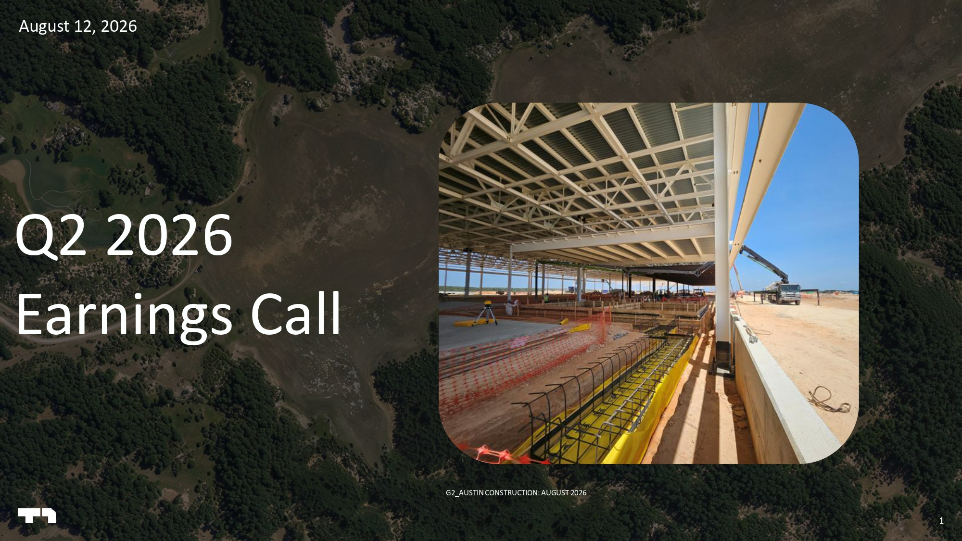
1 1 Q2 2026 Earnings Call August 12, 2026 G2_AUSTIN CONSTRUCTION: AUGUST 2026

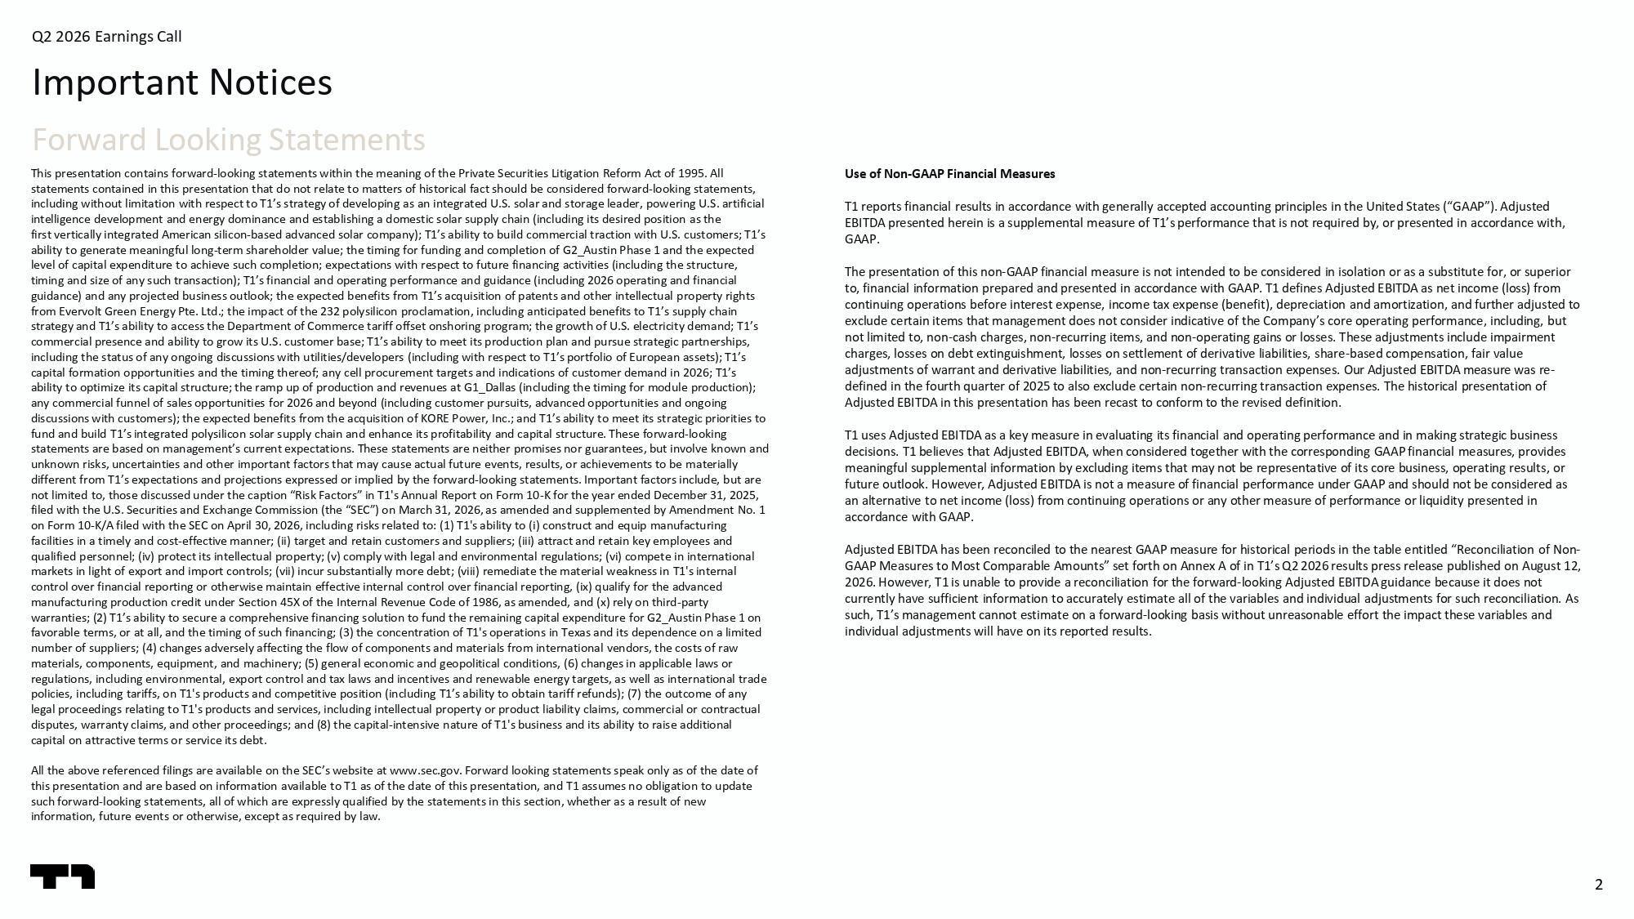
2 Q2 2026 Earnings Call This presentation contains forward - looking statements within the meaning of the Private Securities Litigation Reform Act of 1995 . All statements contained in this presentation that do not relate to matters of historical fact should be considered forward - looking statements, including without limitation with respect to T1’s strategy of developing as an integrated U.S. solar and storage leader, powe rin g U.S. artificial intelligence development and energy dominance and establishing a domestic solar supply chain (including its desired position as the first vertically integrated American silicon - based advanced solar company); T1’s ability to build commercial traction with U.S. customers; T1’s ability to generate meaningful long - term shareholder value; the timing for funding and completion of G2_Austin Phase 1 and the e xpected level of capital expenditure to achieve such completion; expectations with respect to future financing activities (including the structure, timing and size of any such transaction); T1’s financial and operating performance and guidance (including 2026 operating and fi nancial guidance) and any projected business outlook; the expected benefits from T1’s acquisition of patents and other intellectual property rights from Evervolt Green Energy Pte. Ltd.; the impact of the 232 polysilicon proclamation, including anticipated benefits to T1’s sup ply chain strategy and T1’s ability to access the Department of Commerce tariff offset onshoring program; the growth of U.S. electricit y d emand; T1’s commercial presence and ability to grow its U.S. customer base; T1’s ability to meet its production plan and pursue strategic pa rtnerships, including the status of any ongoing discussions with utilities/developers (including with respect to T1’s portfolio of Europe an assets); T1’s capital formation opportunities and the timing thereof; any cell procurement targets and indications of customer demand in 20 26; T1’s ability to optimize its capital structure; the ramp up of production and revenues at G1_Dallas (including the timing for modu le production); any commercial funnel of sales opportunities for 2026 and beyond (including customer pursuits, advanced opportunities and ong oin g discussions with customers); the expected benefits from the acquisition of KORE Power, Inc.; and T1’s ability to meet its str ate gic priorities to fund and build T1’s integrated polysilicon solar supply chain and enhance its profitability and capital structure. These forw ard - looking statements are based on management’s current expectations. These statements are neither promises nor guarantees, but involve kno wn and unknown risks, uncertainties and other important factors that may cause actual future events, results, or achievements to be mat erially different from T1’s expectations and projections expressed or implied by the forward - looking statements. Important factors inclu de, but are not limited to, those discussed under the caption “Risk Factors” in T1's Annual Report on Form 10 - K for the year ended December 31, 2025, filed with the U.S. Securities and Exchange Commission (the “SEC”) on March 31, 2026, as amended and supplemented by Amendmen t N o. 1 on Form 10 - K/A filed with the SEC on April 30, 2026, including risks related to: (1) T1's ability to ( i ) construct and equip manufacturing facilities in a timely and cost - effective manner; (ii) target and retain customers and suppliers; (iii) attract and retain key e mployees and qualified personnel; (iv) protect its intellectual property; (v) comply with legal and environmental regulations; (vi) compet e i n international markets in light of export and import controls; (vii) incur substantially more debt; (viii) remediate the material weakness i n T 1's internal control over financial reporting or otherwise maintain effective internal control over financial reporting, (ix) qualify for the advanced manufacturing production credit under Section 45X of the Internal Revenue Code of 1986, as amended, and (x) rely on third - party warranties; (2) T1’s ability to secure a comprehensive financing solution to fund the remaining capital expenditure for G2_Au sti n Phase 1 on favorable terms, or at all, and the timing of such financing; (3) the concentration of T1's operations in Texas and its depen den ce on a limited number of suppliers; (4) changes adversely affecting the flow of components and materials from international vendors, the cos ts of raw materials, components, equipment, and machinery; (5) general economic and geopolitical conditions, (6) changes in applicable law s or regulations, including environmental, export control and tax laws and incentives and renewable energy targets, as well as int ern ational trade policies, including tariffs, on T1's products and competitive position (including T1’s ability to obtain tariff refunds); (7) th e outcome of any legal proceedings relating to T1's products and services, including intellectual property or product liability claims, commer cia l or contractual disputes, warranty claims, and other proceedings; and (8) the capital - intensive nature of T1's business and its ability to raise additional capital on attractive terms or service its debt. All the above referenced filings are available on the SEC’s website at www.sec.gov. Forward looking statements speak only as of the date of this presentation and are based on information available to T1 as of the date of this presentation, and T1 assumes no obligat ion to update such forward - looking statements, all of which are expressly qualified by the statements in this section, whether as a result of new information, future events or otherwise, except as required by law. Use of Non - GAAP Financial Measures T1 reports financial results in accordance with generally accepted accounting principles in the United States (“GAAP”). Adjus ted EBITDA presented herein is a supplemental measure of T1’s performance that is not required by, or presented in accordance wit h, GAAP. The presentation of this non - GAAP financial measure is not intended to be considered in isolation or as a substitute for, or sup erior to, financial information prepared and presented in accordance with GAAP. T1 defines Adjusted EBITDA as net income (loss) fro m continuing operations before interest expense, income tax expense (benefit), depreciation and amortization, and further adjus ted to exclude certain items that management does not consider indicative of the Company’s core operating performance, including, bu t not limited to, non - cash charges, non - recurring items, and non - operating gains or losses. These adjustments include impairment charges, losses on debt extinguishment, losses on settlement of derivative liabilities, share - based compensation, fair value adjustments of warrant and derivative liabilities, and non - recurring transaction expenses. Our Adjusted EBITDA measure was re - defined in the fourth quarter of 2025 to also exclude certain non - recurring transaction expenses. The historical presentation of Adjusted EBITDA in this presentation has been recast to conform to the revised definition. T1 uses Adjusted EBITDA as a key measure in evaluating its financial and operating performance and in making strategic busine ss decisions. T1 believes that Adjusted EBITDA, when considered together with the corresponding GAAP financial measures, provide s meaningful supplemental information by excluding items that may not be representative of its core business, operating results , o r future outlook. However, Adjusted EBITDA is not a measure of financial performance under GAAP and should not be considered as an alternative to net income (loss) from continuing operations or any other measure of performance or liquidity presented in accordance with GAAP. Adjusted EBITDA has been reconciled to the nearest GAAP measure for historical periods in the table entitled “Reconciliation of Non - GAAP Measures to Most Comparable Amounts” set forth on Annex A of in T1’s Q2 2026 results press release published on August 1 2, 2026. However, T1 is unable to provide a reconciliation for the forward - looking Adjusted EBITDA guidance because it does not currently have sufficient information to accurately estimate all of the variables and individual adjustments for such reconci lia tion. As such, T1’s management cannot estimate on a forward - looking basis without unreasonable effort the impact these variables and individual adjustments will have on its reported results. Important Notices Forward Looking Statements

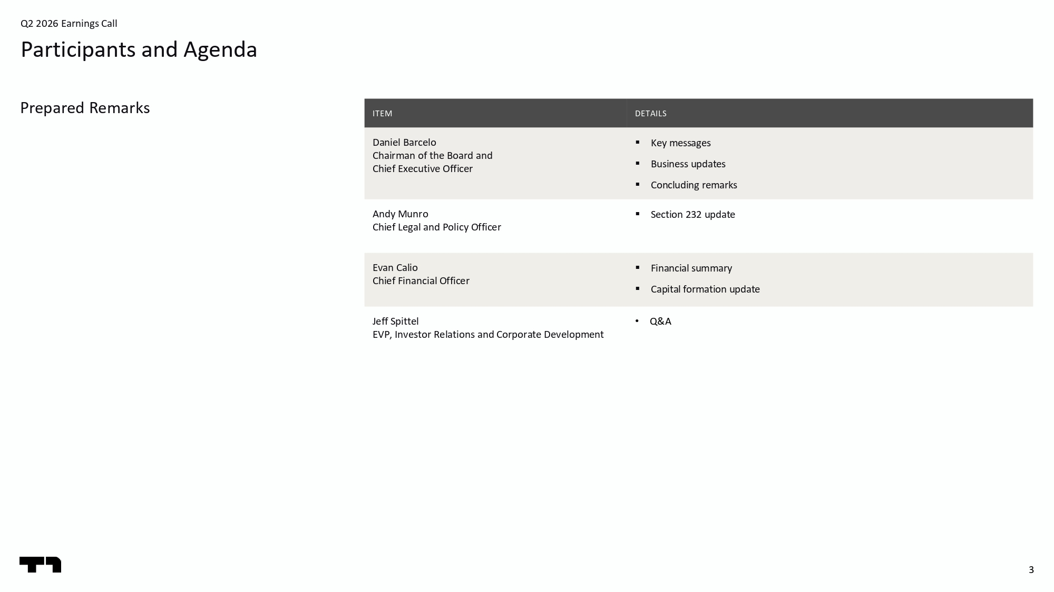
3 Q2 2026 Earnings Call Participants and Agenda Prepared Remarks DETAILS ITEM ▪ Key messages ▪ Business updates ▪ Concluding remarks Daniel Barcelo Chairman of the Board and Chief Executive Officer ▪ Section 232 update Andy Munro Chief Legal and Policy Officer ▪ Financial summary ▪ Capital formation update Evan Calio Chief Financial Officer • Q&A J eff Spittel EVP, Investor Relations and Corporate Development

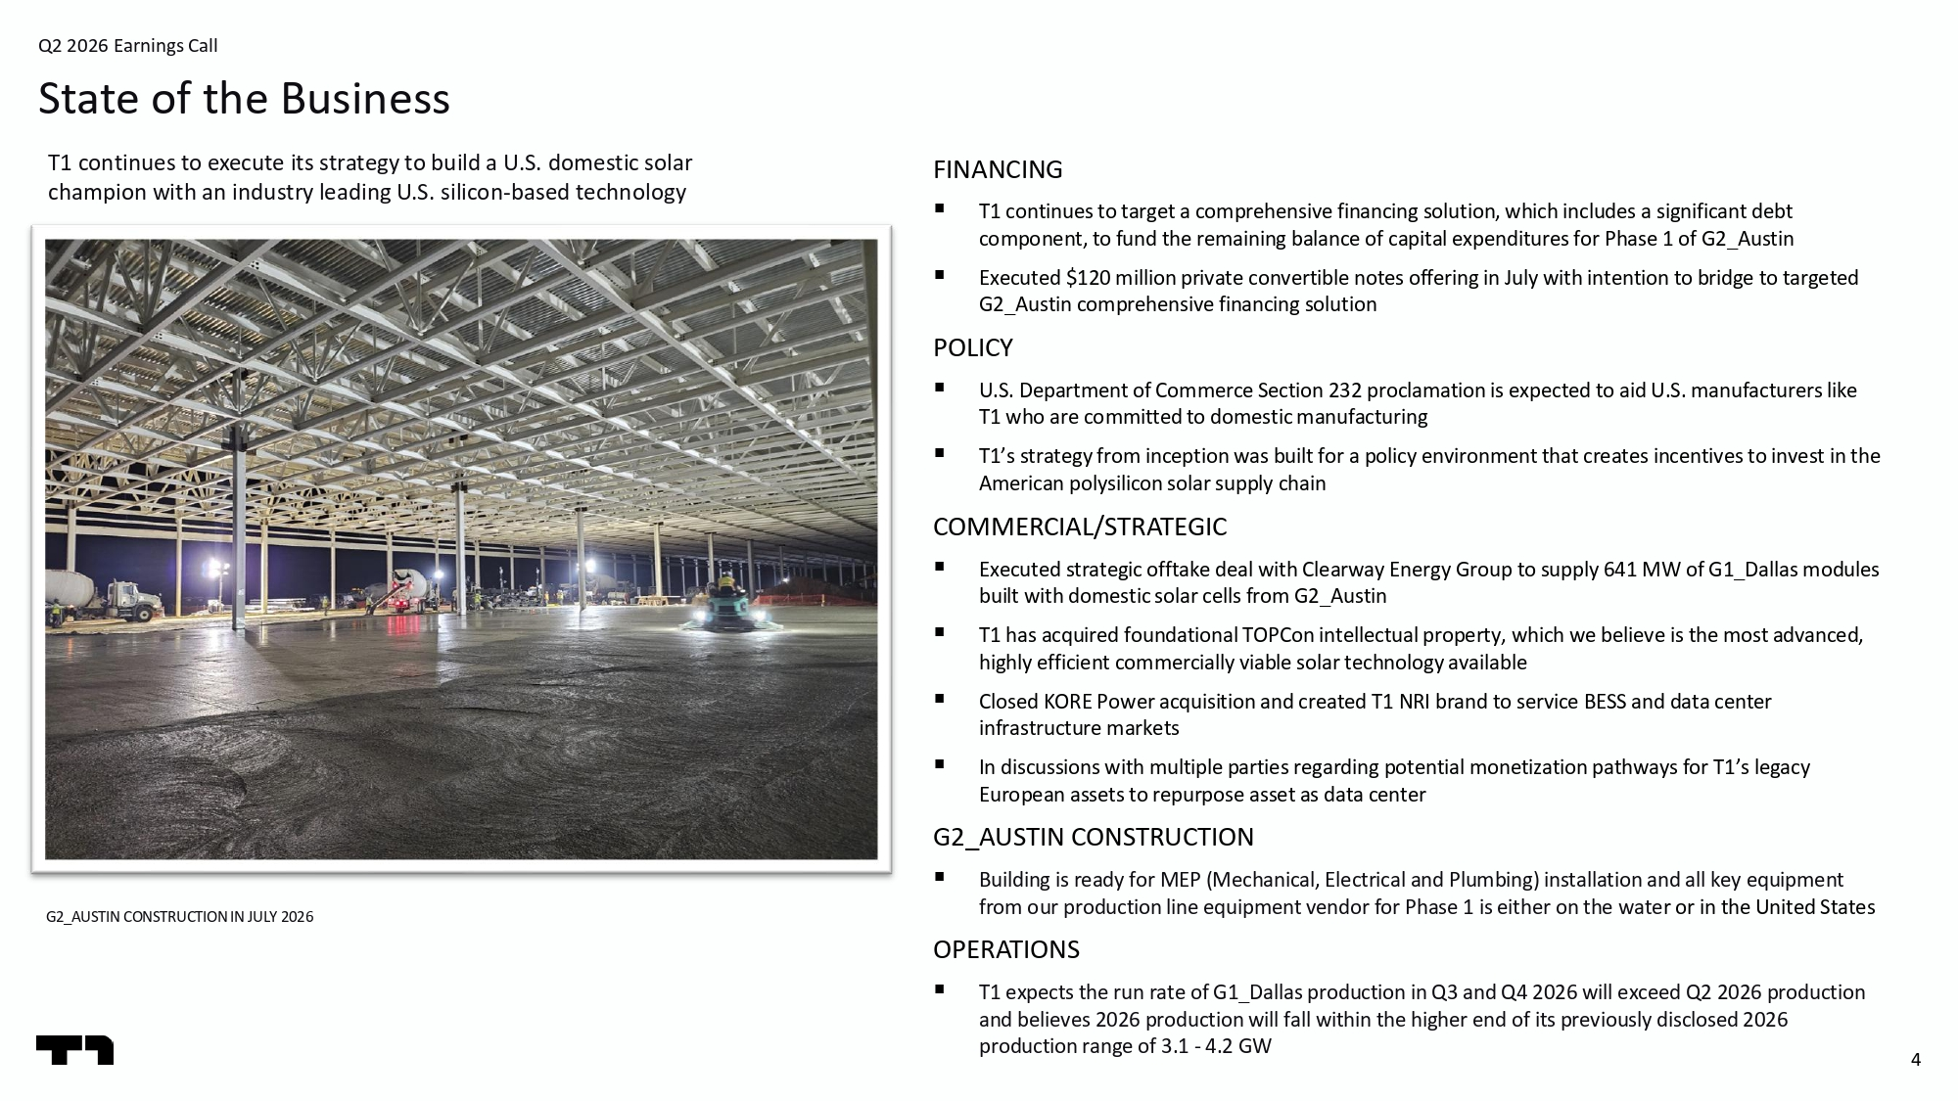
4 Q2 2026 Earnings Call State of the Business G2_AUSTIN CONSTRUCTION IN JULY 2026 FINANCING ▪ T1 continues to target a comprehensive financing solution, which includes a significant debt component, to fund the remaining balance of capital expenditures for Phase 1 of G2_Austin ▪ Executed $120 million private convertible notes offering in July with intention to bridge to targeted G2_Austin comprehensive financing solution POLICY ▪ U.S. Department of Commerce Section 232 proclamation is expected to aid U.S. manufacturers like T1 who are committed to domestic manufacturing ▪ T1’s strategy from inception was built for a policy environment that creates incentives to invest in the American polysilicon solar supply chain COMMERCIAL/STRATEGIC ▪ Executed strategic offtake deal with Clearway Energy Group to supply 641 MW of G1_Dallas modules built with domestic solar cells from G2_Austin ▪ T1 has acquired foundational TOPCon intellectual property, which we believe is the most advanced, highly efficient commercially viable solar technology available ▪ Closed KORE Power acquisition and created T1 NRI brand to service BESS and data center infrastructure markets ▪ In discussions with multiple parties regarding potential monetization pathways for T1’s legacy European assets to repurpose asset as data center G2_AUSTIN CONSTRUCTION ▪ Building is ready for MEP (Mechanical, Electrical and Plumbing) installation and all key equipment from our production line equipment vendor for Phase 1 is either on the wate r or in the United States OPERATIONS ▪ T1 expects the run rate of G1_Dallas production in Q3 and Q4 2026 will exceed Q2 2026 production and believes 2026 production will fall within the higher end of its previously disclosed 2026 production range of 3.1 - 4.2 GW T1 continues to execute its strategy to build a U.S. domestic solar champion with an industry leading U.S. silicon - based technology

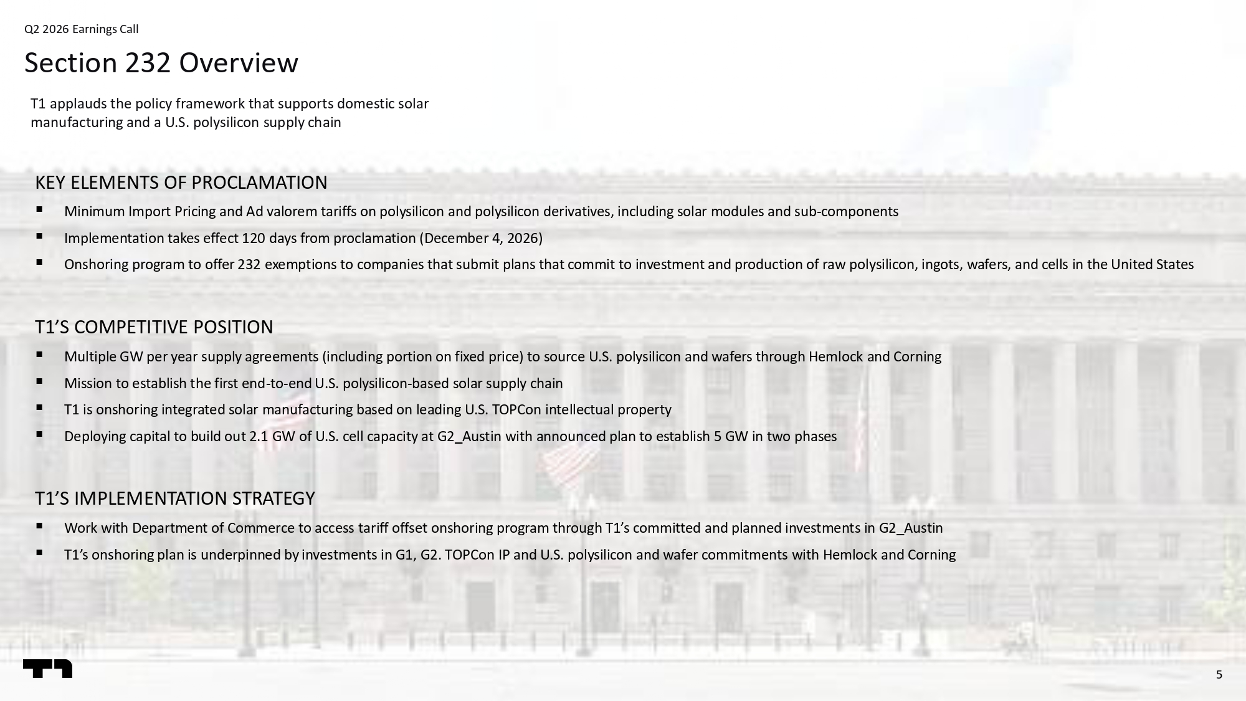
5 Q2 2026 Earnings Call Section 232 Overview KEY ELEMENTS OF PROCLAMATION ▪ Minimum Import Pricing and Ad valorem tariffs on polysilicon and polysilicon derivatives, including solar modules and sub - compon ents ▪ Implementation takes effect 120 days from proclamation (December 4, 2026) ▪ Onshoring program to offer 232 exemptions to companies that submit plans that commit to investment and production of raw poly sil icon, ingots, wafers, and cells in the United States T1’S COMPETITIVE POSITION ▪ Multiple GW per year supply agreements (including portion on fixed price) to source U.S. polysilicon and wafers through Hemlo ck and Corning ▪ Mission to establish the first end - to - end U.S. polysilicon - based solar supply chain ▪ T1 is onshoring integrated solar manufacturing based on leading U.S. TOPCon intellectual property ▪ Deploying capital to build out 2.1 GW of U.S. cell capacity at G2_Austin with announced plan to establish 5 GW in two phases T1’S IMPLEMENTATION STRATEGY ▪ Work with Department of Commerce to access tariff offset onshoring program through T1’s committed and planned investments in G2_ Austin ▪ T1’s onshoring plan is underpinned by investments in G1, G2. TOPCon IP and U.S. polysilicon and wafer commitments with Hemloc k a nd Corning T1 applauds the policy framework that supports domestic solar manufacturing and a U.S. polysilicon supply chain

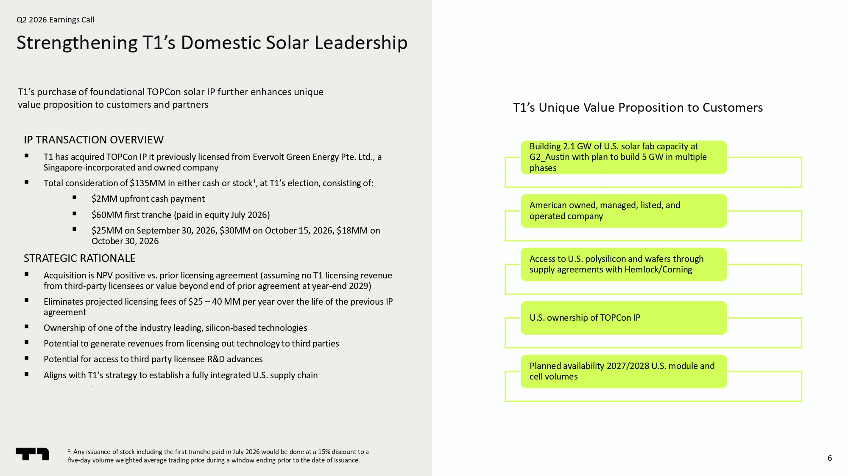
6 Q2 2026 Earnings Call Strengthening T1’s Domestic Solar Leadership IP TRANSACTION OVERVIEW ▪ T1 has acquired TOPCon IP it previously licensed from Evervolt Green Energy Pte. Ltd., a Singapore - incorporated and owned company ▪ Total consideration of $135MM in either cash or stock 1 , at T1’s election, consisting of: ▪ $2MM upfront cash payment ▪ $60MM first tranche (paid in equity July 2026) ▪ $25MM on September 30, 2026, $30MM on October 15, 2026, $18MM on October 30, 2026 STRATEGIC RATIONALE ▪ Acquisition is NPV positive vs. prior licensing agreement (assuming no T1 licensing revenue from third - party licensees or value beyond end of prior agreement at year - end 2029) ▪ Eliminates projected licensing fees of $25 – 40 MM per year over the life of the previous IP agreement ▪ Ownership of one of the industry leading, silicon - based technologies ▪ Potential to generate revenues from licensing out technology to third parties ▪ Potential for access to third party licensee R&D advances ▪ Aligns with T1’s strategy to establish a fully integrated U.S. supply chain ▪ $ T1’s Unique Value Proposition to Customers T1’s purchase of foundational TOPCon solar IP further enhances unique value proposition to customers and partners Building 2.1 GW of U.S. solar fab capacity at G2_Austin with plan to build 5 GW in multiple phases American owned, managed, listed, and operated company Access to U.S. polysilicon and wafers through supply agreements with Hemlock/Corning U.S. ownership of TOPCon IP Planned availability 2027/2028 U.S. module and cell volumes 1 : Any issuance of stock including the first tranche paid in July 2026 would be done at a 15% discount to a five - day volume weighted average trading price during a window ending prior to the date of issuance.

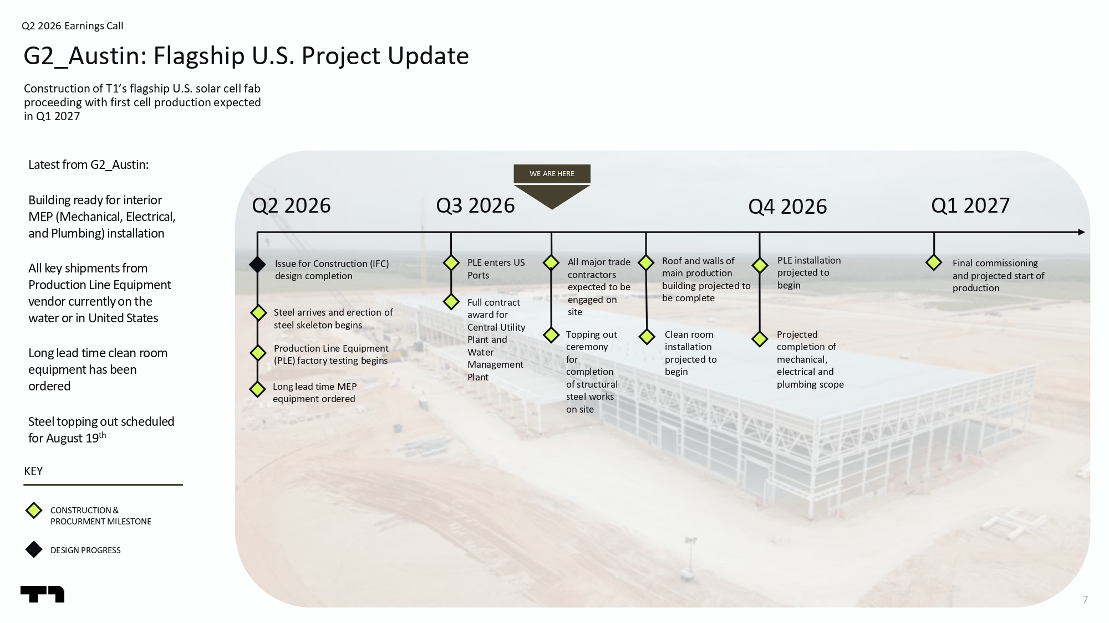
7 Construction of T1’s flagship U.S. solar cell fab proceeding with first cell production expected in Q1 2027 Q2 2026 Earnings Call G2_Austin: Flagship U.S. Project Update Latest from G2_Austin: Building ready for interior MEP (Mechanical, Electrical, and Plumbing) installation All key shipments from Production Line Equipment vendor currently on the water or in United States Long lead time clean room equipment has been ordered Steel topping out scheduled for August 19 th CONSTRUCTION & PROCURMENT MILESTONE DESIGN PROGRESS Q3 2026 Q4 2026 Steel arrives and erection of steel skeleton begins Production Line Equipment (PLE) factory testing begins Long lead time MEP equipment ordered PLE enters US Ports All major trade contractors expected to be engaged on site Issue for Construction (IFC) design completion Full contract award for Central Utility Plant and Water Management Plant Roof and walls of main production building projected to be complete PLE installation projected to begin Final commissioning and projected start of production Q2 2026 WE ARE HERE KEY Q1 2027 Topping out ceremony for completion of structural steel works on site Projected completion of mechanical, electrical and plumbing scope Clean room installation projected to begin

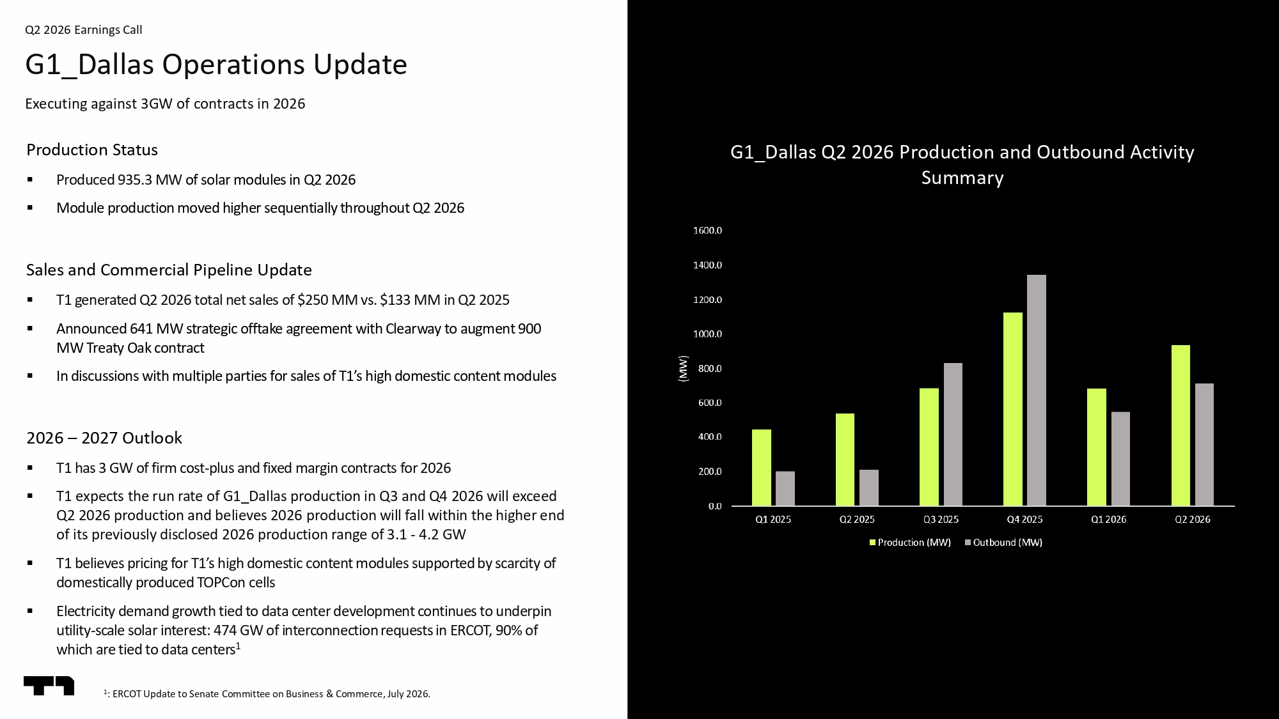
8 Q2 2026 Earnings Call G1_Dallas Operations Update Executing against 3GW of contracts in 2026 G1_Dallas Q2 2026 Production and Outbound Activity Summary Production Status ▪ Produced 935.3 MW of solar modules in Q2 2026 ▪ Module production moved higher sequentially throughout Q2 2026 Sales and Commercial Pipeline Update ▪ T1 generated Q2 2026 total net sales of $250 MM vs. $133 MM in Q2 2025 ▪ Announced 641 MW strategic offtake agreement with Clearway to augment 900 MW Treaty Oak contract ▪ In discussions with multiple parties for sales of T1’s high domestic content modules 2026 – 2027 Outlook ▪ T1 has 3 GW of firm cost - plus and fixed margin contracts for 2026 ▪ T1 expects the run rate of G1_Dallas production in Q3 and Q4 2026 will exceed Q2 2026 production and believes 2026 production will fall within the higher end of its previously disclosed 2026 production range of 3.1 - 4.2 GW ▪ T1 believes pricing for T1’s high domestic content modules supported by scarcity of domestically produced TOPCon cells ▪ Electricity demand growth tied to data center development continues to underpin utility - scale solar interest: 474 GW of interconnection requests in ERCOT, 90% of which are tied to data centers 1 1 : ERCOT Update to Senate Committee on Business & Commerce, July 2026.

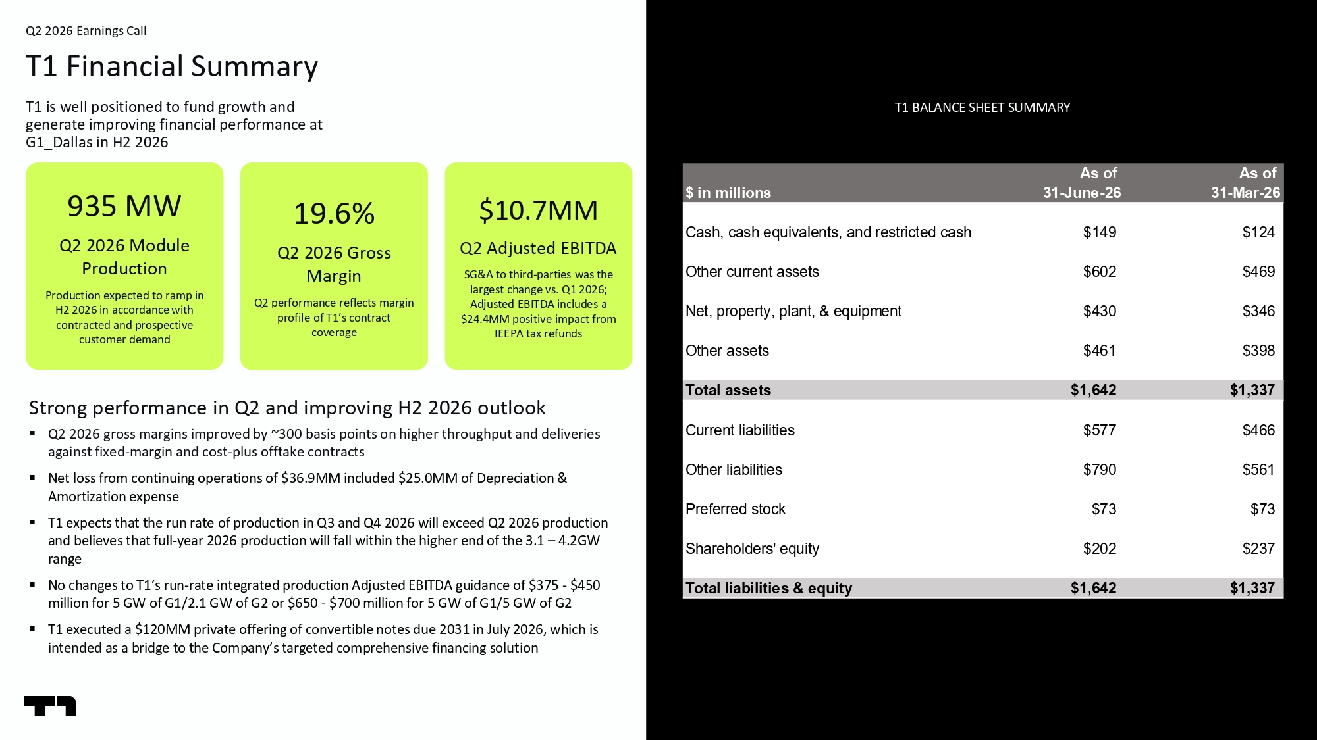
9 Q2 2026 Earnings Call T1 Financial Summary T1 is well positioned to fund growth and generate improving financial performance at G1_Dallas in H2 2026 T1 BALANCE SHEET SUMMARY 935 MW Q2 2026 Module Production Production expected to ramp in H2 2026 in accordance with contracted and prospective customer demand 19.6% Q2 2026 Gross Margin Q2 performance reflects margin profile of T1’s contract coverage $10.7MM Q2 Adjusted EBITDA SG&A to third - parties was the largest change vs. Q1 2026; Adjusted EBITDA includes a $24.4MM positive impact from IEEPA tax refunds Strong performance in Q2 and improving H2 2026 outlook ▪ Q2 2026 gross margins improved by ~300 basis points on higher throughput and deliveries against fixed - margin and cost - plus offtake contracts ▪ Net loss from continuing operations of $36.9MM included $25.0MM of Depreciation & Amortization expense ▪ T1 expects that the run rate of production in Q3 and Q4 2026 will exceed Q2 2026 production and believes that full - year 2026 production will fall within the higher end of the 3.1 – 4.2GW range ▪ No changes to T1’s run - rate integrated production Adjusted EBITDA guidance of $375 - $450 million for 5 GW of G1/2.1 GW of G2 or $650 - $700 million for 5 GW of G1/5 GW of G2 ▪ T1 executed a $120MM private offering of convertible notes due 2031 in July 2026, which is intended as a bridge to the Company’s targeted comprehensive financing solution As of As of $ in millions 31-June-26 31-Mar-26 Cash, cash equivalents, and restricted cash $149 $124 Other current assets $602 $469 Net, property, plant, & equipment $430 $346 Other assets $461 $398 Total assets $1,642 $1,337 Current liabilities $577 $466 Other liabilities $790 $561 Preferred stock $73 $73 Shareholders' equity $202 $237 Total liabilities & equity $1,642 $1,337

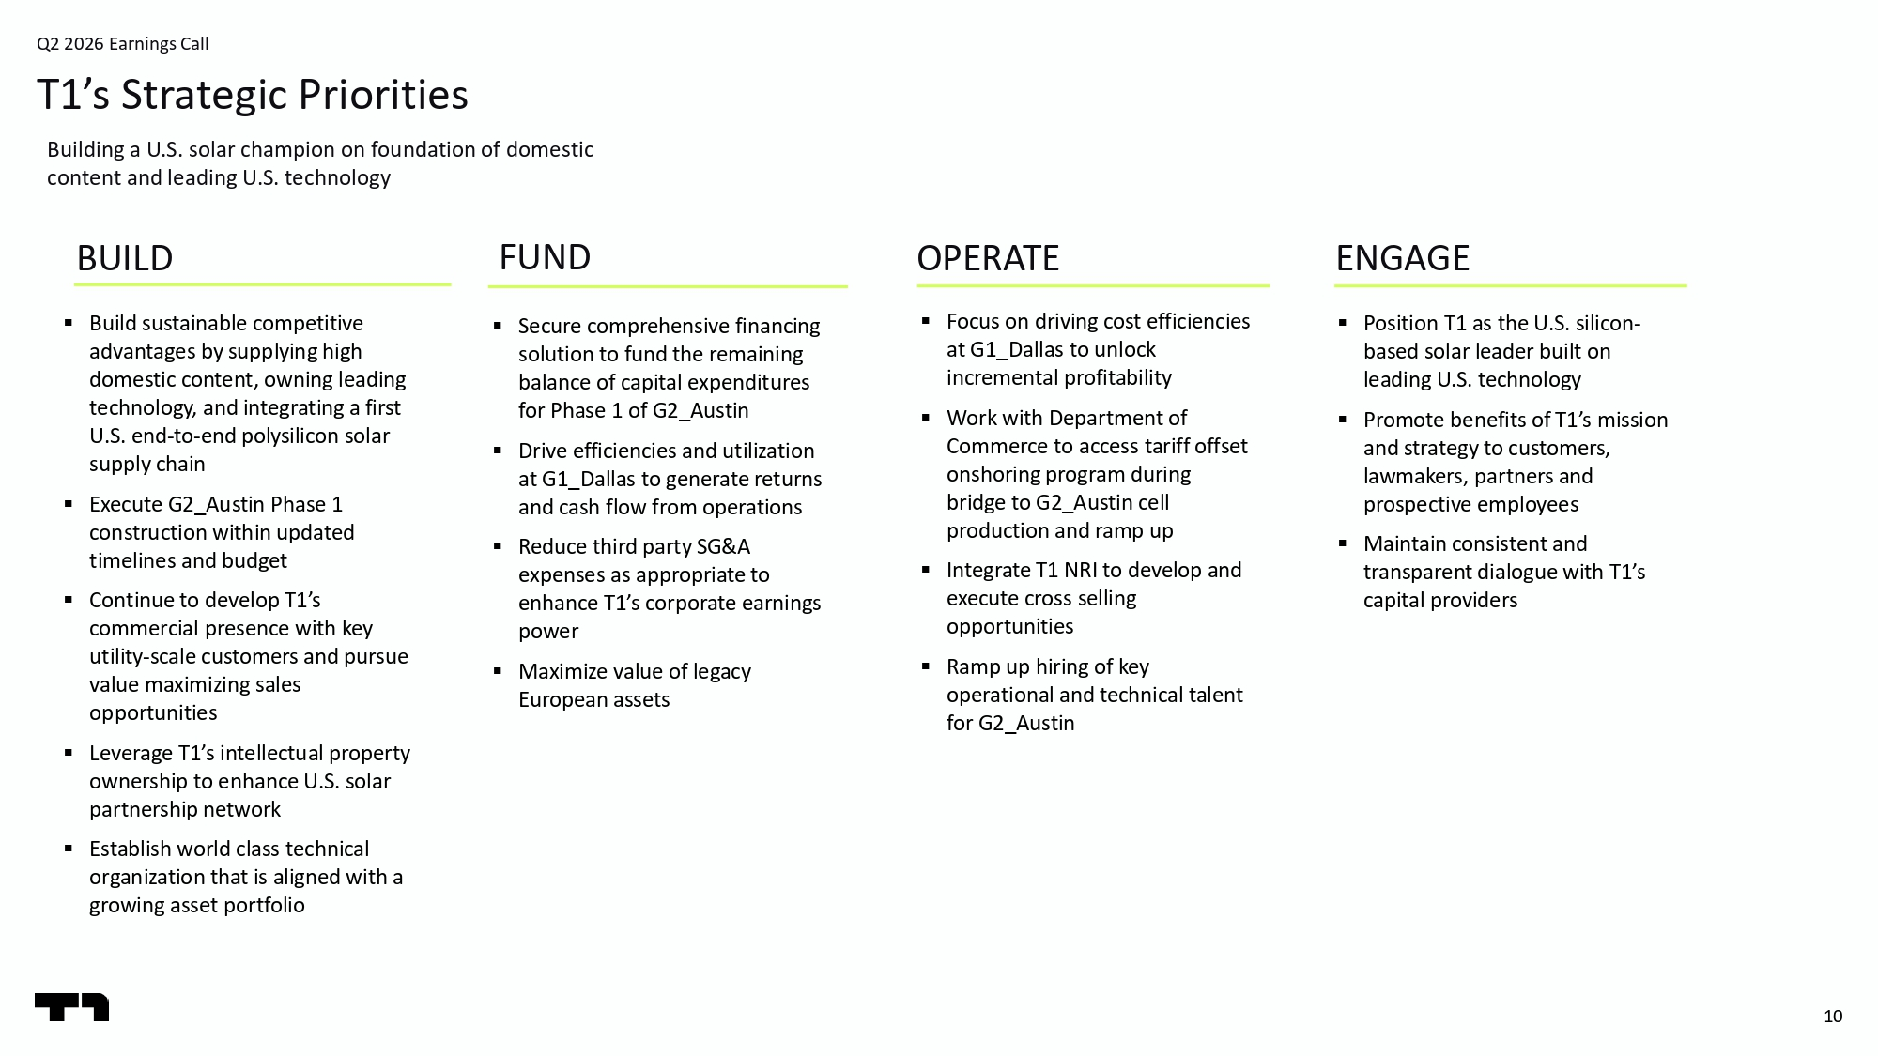
10 ▪ Secure comprehensive financing solution to fund the remaining balance of capital expenditures for Phase 1 of G2_Austin ▪ Drive efficiencies and utilization at G1_Dallas to generate returns and cash flow from operations ▪ Reduce third party SG&A expenses as appropriate to enhance T1’s corporate earnings power ▪ Maximize value of legacy European assets BUILD ▪ Build sustainable competitive advantages by supplying high domestic content, owning leading technology, and integrating a first U.S. end - to - end polysilicon solar supply chain ▪ Execute G2_Austin Phase 1 construction within updated timelines and budget ▪ Continue to develop T1’s commercial presence with key utility - scale customers and pursue value maximizing sales opportunities ▪ Leverage T1’s intellectual property ownership to enhance U.S. solar partnership network ▪ Establish world class technical organization that is aligned with a growing asset portfolio Building a U.S. solar champion on foundation of domestic content and leading U.S. technology Q2 2026 Earnings Call T1’s Strategic Priorities FUND ENGAGE ▪ Position T1 as the U.S. silicon - based solar leader built on leading U.S. technology ▪ Promote benefits of T1’s mission and strategy to customers, lawmakers, partners and prospective employees ▪ Maintain consistent and transparent dialogue with T1’s capital providers OPERATE ▪ Focus on driving cost efficiencies at G1_Dallas to unlock incremental profitability ▪ Work with Department of Commerce to access tariff offset onshoring program during bridge to G2_Austin cell production and ramp up ▪ Integrate T1 NRI to develop and execute cross selling opportunities ▪ Ramp up hiring of key operational and technical talent for G2_Austin

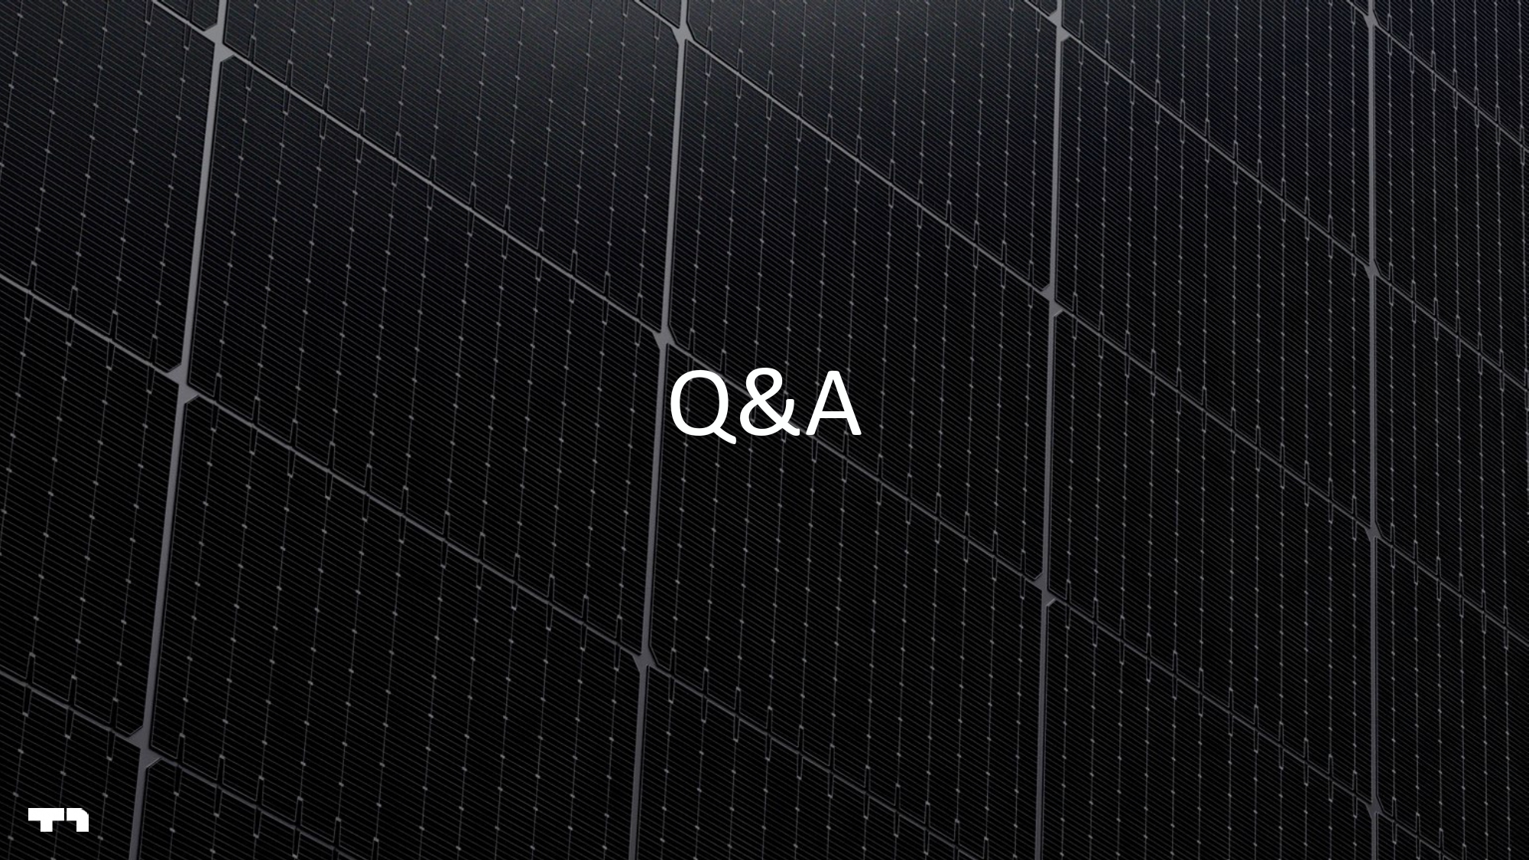
11 Q&A

